Data conversion and data migration – Appendix I
NRFP Requirement | The following describes the desirable provisions for section 3.2.7 (Data Conversion and Data Migration) of the NRFP.

Table I  11 |  | Data Conversion and Data Migration
1.0 | Data Governance and Stewardship
The Pre-Qualified Proponent should provide a preliminary data governance strategy. The strategy should include:
- an approach to confirming data owners, data stewards and system information stewards for each of the identified data objects forming part of the ERP Project scope;
- an approach showing the mandates and duties of the owners and stewards to support the development of accurate and representative data during the project and also once in production status.
The Proposal should:
- provide a detailed approach and high level strategy on how the Pre-Qualified Proponent will approach, establish and confirm a data governance strategy across the Province.
Pre-Qualified Proponent Comments:
  - provide a detailed approach and high level strategy on how the Pre-Qualified Proponent will approach, establish and confirm a data governance strategy across the Province.
Design Time Data Governance framework for the GoA
Deloitte has a leading industry standard data governance framework that will be adapted to fulfill GoA requirements. Data governance is a critical aspect of project implementation, which supports business continuity and critical data availability in a new system. We will work with you collaboratively to tailor the Deloitte Framework to develop a GoA-specific data governance approach and strategy.
For illustrative purposes, we have provided an overview of our Data Governance Framework below including benefits to the GoA.
Figure I1: Deloitte Data Governance Framework
Compliance
Processes
Policies
Data
Architecture
Technology
Organization
Data
Governance
Framework
View information
as a strategic asset
Enabled with a comprehensive change mgmt program
Organizations chartered with administering data management activities provide a responsible network of dedicated and/or virtual resources to deliver quality enterprise master data
Technology supporting common information exchange solutions, workflow and business rules functionality, and user presentation/portal
Compliance establishes measures for monitoring data management performance and actions to continuously improve master data
Process establishes structures defining how data governance policies, processes, standards, and master data are created and modified

Policy refers to master data management guidelines and principles for enforcing data standards, processes, and policies

Data Architecture includes enterprise data standards, business information model, metadata dictionary, and security & privacy
Linked to strategic initiatives
Driven
by business value
The four triangles focuses on the business priorities, viz: Information as a strategy asset; Business value drivers; Change management; and Link to strategic initiatives.

Components | Key actions | Business value to the GoA
Organization | - Establish a central organization to manage, deliver, and QA master data across the organization  - Enable the business areas to move beyond a project-by-project approach to enterprise master data architectures  - Establish a data management council composed of IT and business specialists that, for new data, governs decisions, such as new subject areas, new data sources, and new business problems to be solved with the data  - Establish global accountability for creating, managing, and administering the domain specific master data elements to enable a single view of master data  - Create the concept of specialists in master data domains, to help provide accuracy, consistency, and reliability of rules  - Establish an organization that manages master data issues and manages effective resolution | Reduce Overhead Cost  - Given the different systems at play for GoA, many people may be trying to do the same thing simultaneously with inconsistent results. In the future, we will aim to have individual owners based on a common dataset.  - Improved productivity and more time spend on value-added work.  Specialization  - Data specialists can focus on well-defined and specific master data areas in order to achieve a single view of a customer, product, or vendor. Centralized functions will allow for more accurate results and greater success.  Accountability  - Whether you are a specialist working in a customer administration role or a business representative belonging to a master data governance council, holding team members accountable will improve effectiveness
Technology | - Establish technology architecture that defines the required data tools and system linkages to fulfill the enterprise data management objectives  - Deploy an architecture that maintains a consistent view across all core master data elements as needed to serve the business needs and support agility  - Use the data profiling ability of available tools to facilitate data cleansing  - Configure tools to automate the data creation and replication process  - Select the right technology partners that can fulfill all business requirements  - Choose a tool with sufficient workflow and control capabilities to simplify and automate maintenance and governance processes  - Put the right components of the tool (Enterprise Application Integration Layer) to use so that, master data gets distributed to all corporate level systems quickly and accurately | Reduce IT costs:  - Helps GoA Implement a consistent infrastructure, which reduces time to analyze and design new integration solutions  - Create automated workflow processes, which users leverage to manage data processes across the GoA  - Create a consistent data architecture and data integration infrastructure that reduces complexity, redundancy, and tool proliferation, which in turn reduces software licensing and training costs, as well as overhead due to complexity  Flexible and agile architecture:  - Fast and reliable access to consolidated data reduces time and cost for retrieving data from disparate systems  - Standardized infrastructure and approach reduces infrastructure complexity, reducing time needed to adapt business processes to changing competitive forces
Architecture | - Define enterprise master data standards and supporting data architectures including definition of business rules  - Establish standard business rules and conformed dimensions within each business area and function  - Define a common language to define and create new elements, as necessary—all of which should be documented in a corporate data dictionary (or metadata repository)  - Embrace rigid data modeling standards  - Define a structured game plan to provide standard structures, naming conventions, and data standards to promote consistency and standardization  - Provide policy and direction to provide data integrity, maximize the use of data, and minimize the costs associated with data collection and data management  - Migrate to data standards over time using cross-reference maps in the interim | Value Proposition  - Helps GoA achieve accurate, consistent, and reliable data  - Increased data quality and elimination of redundant data stores in the GoA footprint  - Promotes single version of the truth  - Consolidated data delivery and consistent approach for reporting  - Dashboards and portals improve transparency
Policies | - Data governance policies must be institutionalized to provide structure and guidance  - Data governance council must be established early and at the time when policies and standards are being proposed and drafted  - Define the organizational mandates for the management of master data  - Establish how the organization will deliver upon the guiding principles in business terms  - Identify key roles within the organization—roles that will be held accountable for the execution of these policies | Value Proposition  - Provides clear and consistent guidelines for GoA employees, which results in better data quality  - Drives accountability across all levels of the organization, improving employee accountability  - Promotes a single version of the truth across each master data subject
Processes | - Establish a process to add, maintain, delete, and archive master data records that clearly describes the integration points and handoffs  - Establish processes to manage data exchange, issue resolution, change control, and data quality  - Establish a process that simplifies transactions, automates steps, and reduces manual efforts  - Establish Service Level Agreements (SLA) to set expectations related to administration latency  - Provide formal data quality testing procedures and control processes are followed | Value Proposition  - Reduces overhead cost for GoA  - Creates processes that automate workflow and reduce unnecessary manual efforts by GoA users  - Creates controls within the processes to see that changes are adequately approved and only approved changes are moved into production  - Satisfies GoA compliance requirements  - Supports SOX compliance with data change approvals, including audit procedures
Compliance | - Coordinate the planning and execution of data quality and compliance audit programs  - Test adherence to data standards and work with master data maintenance teams and/or IT to resolve issues  - Work to align compliance with internal controls framework, with a focus on cause of change reconciliations  - Create and administer the issue tracking and resolution process  - Report on data quality metrics, service level agreements, and other operational statistics | Value Proposition  - Adherence to SLAs, standards, and policies will become part of the key performance measures, in addition to data accuracy  - Consistent and reliable data that can be more seamlessly integrated and reported at an enterprise-level, independent of application and departmental boundaries  - Improve data quality resulting in greater business confidence in information  - Reduce proliferation of departmental solutions that arise due to lack of clear policies  - Promotes a single version of the truth across each master data subject
We believe the same Governance constructs that will be deployed in the production environment should be leveraged to make the data design decisions within the scope of Project and validate the testing and quality of the data being loaded into the production systems. Our Design Time Data Governance Model brings together a cross functional group of stakeholders and leverages that group to make key data decisions and resolve cross functional issues that impact the master data solution. Our approach for Master Data Management and Data Governance for the GoA will:
- Establish baseline master data standards and maintenance processes required to support the in scope processes
- Define data standards and quality metrics based on the requirements of the business. The data standards will be harvested from the outputs from the business process design work and aggregated into a single definition for each key data attribute. Data standard decisions will be made by a cross functional group of stakeholders to see that no standard definition is based on the needs of just one or two functions within the organization
- Design policies and processes for ongoing data quality monitoring, data change control and issue remediation. The content for the data standards, policies and roles will be driven by the requirements produced by the process design and the data management solution specifications. The data quality reports required to monitor data quality in production will be built and tested by both the technical team as well as key stakeholders that are part of the cross functional Data Team for each domain
- Integrate a set of data quality responsibilities across the roles with data maintenance responsibilities and make data governance part of the GoA’s strategic and operational processes
Data Governance Design
During the data governance design and development process, the team will develop data governance policies and procedures to be implemented by the GoA during design phase of the project.
The objectives of the Data Governance thread will be to define the roles and responsibilities of the data governance organization, document the new policies and procedures required for the project.
Phase | Activity | Deliverable | Deloitte | GoA
Data Governance Discovery & Analysis | - Review existing data governance framework, policies, and procedures  - Inventory current information environment for information categories (transaction, control, performance, and regulatory)  - Confirm critical data sources, uses, and stores  - Engage data owners and stewards to identify data quality issues | Current state assessment | Jointly create | - Jointly create  - Approve
Data Governance Discovery & Analysis |  | Data governance scope | Jointly create | - Jointly create  - Approve
Data Governance Discovery & Analysis |  | Data quality issues log | Jointly create | - Jointly create  - Approve
Data Governance Design | - Develop guiding principles for governance  - Identify governance processes for information categories (oversight, execution, etc.).  - Prioritize areas for data standardization  - Identify authoritative data sources | Governance model | Jointly create | - Jointly create  - Approve
Data Governance Design |  | Update policies and procedures | Jointly create | - Jointly create  - Approve
Data Governance Roadmap Development | - Assess impact on organization: data owners, customers, and stewards  - Develop action plan recommendation for resolving data quality issues (data cleanup, reference data review, relationships, and volumes)  - Develop communications strategy | Impact assessment | Jointly create | - Jointly create  - Approve
Data Governance Roadmap Development |  | Change and communication plan | Jointly create | - Jointly create  - Approve

Table I |  | Data Conversion and Data Migration
2.0 | Data Conversion
The Pre-Qualified Proponent should provide a preliminary data conversion strategy. The strategy should include, but is not limited to:
- scope, approach and plan to assist the Province to:
- identify data that should be converted;
- convert static files (master data like employee information);
- convert dynamic open data/files (transaction data like open purchase orders); and
- convert historical data;
- an approach for data mapping from the current solution(s) to the ERP Solution;
- an approach to complete data conversion integration testing; and
- an approach to quality assurance and data integrity.
The Proposal should:
- identify pre-requisite and/or co-requisite requirements or dependencies for the recommended data conversion process outlining any out of project scope dependencies;
- describe the approach toward data conversion and what methods, tools, templates, or processes the Pre-Qualified Proponent have found helpful in past implementations; detailing the key activities to provide accurate, representative and cleansed data of each phase you propose in your conversion approach conversion;
- describe plans to manage dependency and data change management taking place during the course of the project execution (between data conversion and Implementation);
- indicate how quality assurance is embedded and demonstrated throughout the data conversion process;
- confirm the organizational support that should be expected to support the continued data extracts and conversion activities;
- describe expectations from the Province to see that data conversion is effective and efficient;
- list any assumptions or dependencies on which the proposed design is based;
- provide sample data conversion deliverables including mapping document, business rules document etc.;
- provide a sample data conversion plan including tasks, milestones, deliverables, and resources;
- describe any tools, processes or methods available for data migration;
- describe plans to manage dependency between data migration and Implementation;
- describe risks and recommend risk remedial actions for data migration;
- describe expectations from the Province to see that data migration is effective and efficient; and
- provide sample data migration deliverables including data validation reporting.
Pre-Qualified Proponent Comments
We will use our Enterprise Value Delivery (EVD) methodology for Oracle Cloud which we have tailored for the GoA to address data conversion activities. The GoA Oracle Cloud program will start with a Mobilize phase, then iterative agile sprints to Architect, Configure & Prototype, and Test during the Adapt phase, followed by Deploy and Support phases that align with each of the business initiatives in our timeline. End-to-end testing will be conducted at the conclusion of all sprints. By incorporating agile practices to enhance our traditional methods within the parameters of the implementation scope, we have created an approach that is responsive and adaptable to change.
Figure I2: Deloitte Enterprise Value Delivery Methodology
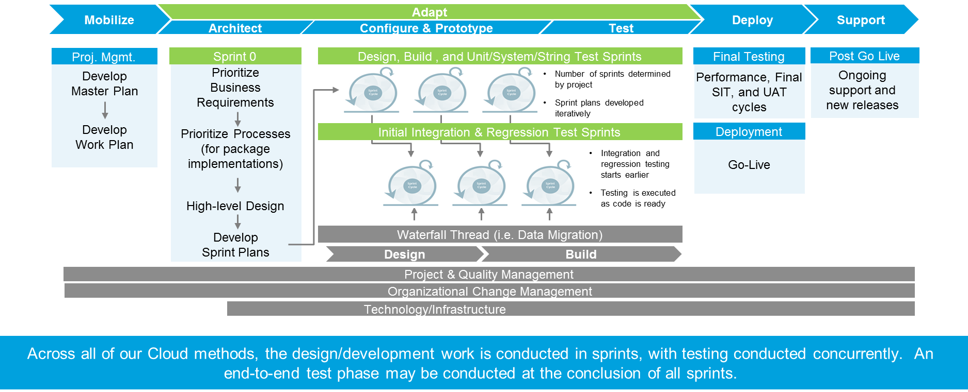
  - identify pre-requisite and/or co-requisite requirements or dependencies for the recommended data conversion process outlining any out of project scope dependencies;
Below are some of the pre-requisites and dependencies with the data conversion process.
- GOA will pre-cleanse data. Deloitte may consider Oracle Enterprise Data Quality or third-party data cleansing tools that may be used for automated cleansing or enrichment.
- Decisions about the necessity for cleansing will be based on the quality of the data in the legacy system. If the quality of the data in the legacy system (s) does not meet the requirements of the target system, a process needs to be developed to correct or cleanse the data. For instance, this may happen when the target system has a data element that is mandatory but it is not required in the source legacy system.
- Data Governance that defines the policies and procedures is available to the project.
- Legacy systems must be able to produce data extracts in specified CSV format
- Availability of GoA resources – includes legacy system SMEs, DBAs and business analysts to validate data conversion
- Maintain software currency with cloud and legacy systems to obtain vendor support with application
- Effective procedures for data cleansing, data conversion, and data maintenance activities in terms of scope, responsibilities and dealing with sensitive data
  - describe the approach toward data conversion and what methods, tools, templates, or processes the Pre-Qualified Proponent have found helpful in past implementations; detailing the key activities to ensure accurate, representative and cleansed data of each phase you propose in your conversion approach conversion;
The diagram below provides an overview of the conversion process using a phased approach: Data Extraction, Data Cleansing, Data Transformation, Data Loading, and Data Validation and Reconciliation. Each of the phases has additional tasks as illustrated in the figure below.
Stage 1: Data extraction
This involves identifying key data elements from legacy source systems that map to cloud ERP systems.
Data will be extracted from the different legacy systems and loaded to corresponding tables in the landing area with reports/logs of extracted data. In certain instances, transformations can be performed on the legacy systems, including converting packed decimal to text, standardizing field sizes and lengths, standardizing record lengths, and replace NULLS with spaces to prepare the data for loading into the target database.
Stage 2: Data cleansing
We understand the significance with data cleansing and prepared an approach from previous projects that we can bring to the GoA. The steps at a high-level are summarized below:
- Load uncleansed data into staging area in source systems
- Apply data transformation in staging area in source systems
- Data cleansing manually / by using tool in source systems
- Extract data out of source system
- Extract cleansed data into a file for business sign off
- Use the cleansed data to generate conversion data files using Oracle Cloud ERP templates
The following table outlines the specific areas where data cleansing would be applicable.
Parameters | Description | Relevance
Data Duplication | Identifies presence of redundant data. Promotes a single version of data to avoid contradictory analyses. | Multiple versions of data causes confusion and control issues e.g. Tax Payer ID
Data Format | Describes the appropriate level of detail in the data that a field is supposed to follow (e.g. data type, width, and mask). | Affects the ability to analyze the data due to discontinuities and difficulties reconciling data Customer Name (Sentence Case or Upper Case)
Data Correctness | Describes the truth of data and certifies that systems are reporting consistent and accurate information. | Causes improper billing, erroneous account reconciliation(e.g. Bank Account IBAN)
Data Completeness | Describes the presence or absence of data in addition to the data’s ability to answer relevant business questions. | Produces incorrect results due to missing data (e.g. Address Validation)
Business Rule Relevance | Describes the relevance of domain-specific business rules, constraints and cross-field validation. | Lack of consistent business rules leads to miscommunication between parties and erroneous data in the system
Data Definition Consistency | Identifies a common perception of data and conveys whether one can truly and clearly understand what the data implies. | Numerous definitions for the same data causes undue confusion in its interpretation, leading to contradictory reporting and analysis.
Referential Integrity | Inspections for foreign key violations, orphaned entities, broken relationships, and discontinuities. | Difficulties in connecting data and identifying relationships for reporting purposes due to broken linkages.
Stage 3: Data Transformation
Data transformation is based on the concept of Extract, Transform, and Load (ETL). Data conversion into Oracle ERP Cloud is approached differently from a traditional implementation. Oracle provides upload templates in the form of File Based Data Integration (FBDI) and Application Desktop Framework Desktop Integration (ADFdi) to facilitate import of data. These templates are in place for a majority of financial master and transactional data entities.
ETL Task | Description | Tool
Extract | Data is extracted in pre-defined templates from legacy system(s) | Legacy system specific extraction routines need to be built to create output files matching the csv file format of FBDI templates
Transform | Extracted data is loaded into staging table and mapped to align with Oracle ERP Cloud data model | Transformations should be performed wherever applicable in the source legacy system
Load | Data is loaded into Oracle ERP Cloud Application | Deloitte Cloud Conversion Accelerator tool, Oracle delivered File Based Loader (FBDI) tool
The following diagram illustrates the Extract, Transform and Load process with conversions.
Stage 4: Data Loading
There are two supported techniques to load data into Oracle ERP Cloud. During implementation, Deloitte will tailor its conversion process to address GoA’s specific needs. In addition, Deloitte will leverage its deep industry understanding for public sector and Oracle ERP Cloud to deliver a library of simplified templates that allows seamless mapping between source and destination data entities, a tool that enables end to end tracking of data being converted making it fully reconcilable with the source with complete traceability and a detailed “lessons learned” documents that enables us to work quickly through workarounds to known product issues.
Manual Conversion: This approach makes use of Oracle’s prescribed spreadsheet templates such as FBDI and ADFdi. Data is loaded into these templates and the process is executed manually to perform end to end conversion.
Automated Conversion (using Deloitte’s Cloud Conversion Accelerator): Deloitte Cloud Conversion Accelerator significantly reduces efforts involved in building a conversion, enforces a common framework and ensures consistency. It automates the steps involved in FBDI approach to import data into Oracle Cloud as illustrated in the figure below.
1. The source application create the csv data extract files in the FBDI format and place the files in secured file server location.
2. The batch file is verified before the import process is triggered.
3. The tool requires UCM account details for ERP Cloud, import process parameters and notification details followed by which the import then process is triggered on confirmation.
4. The final step is generating the conversion report for verification.

2. Verify batch & validate import data
1. Setup & Import data for conversion

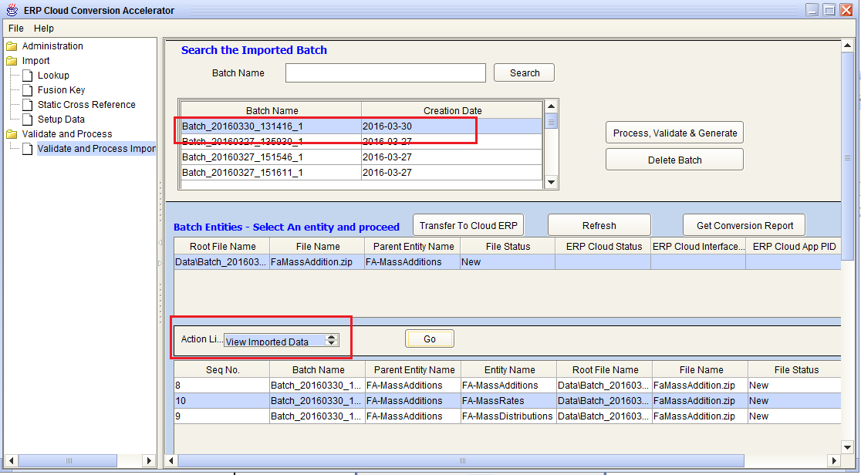
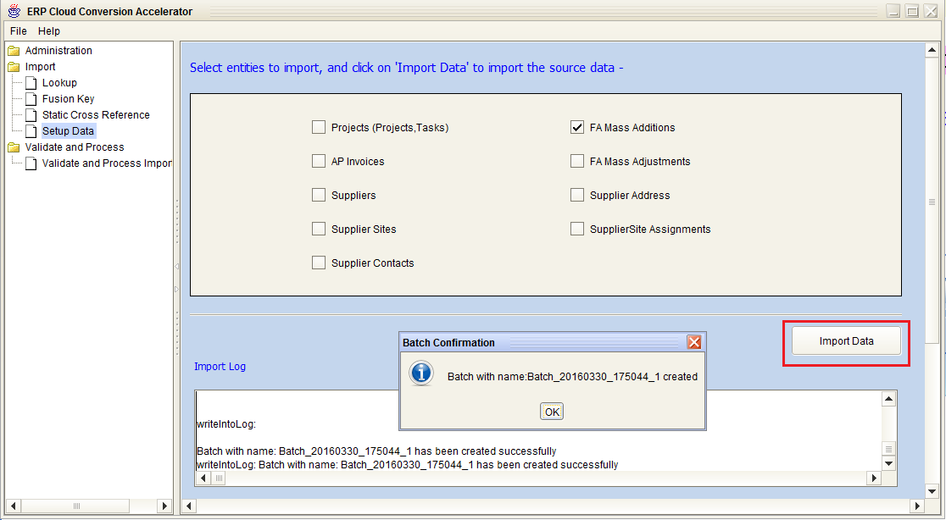

4. Get the conversion report for verification
3. Transfer batch to ERP Cloud
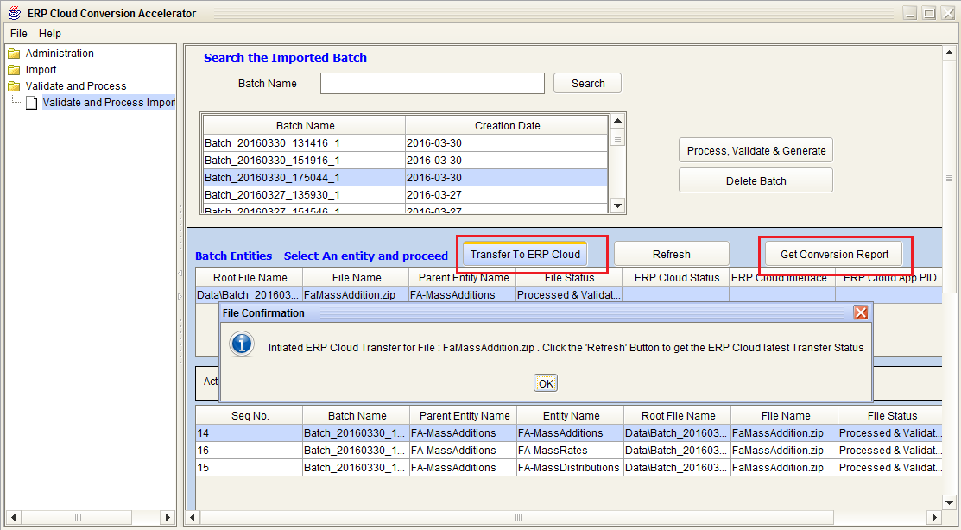
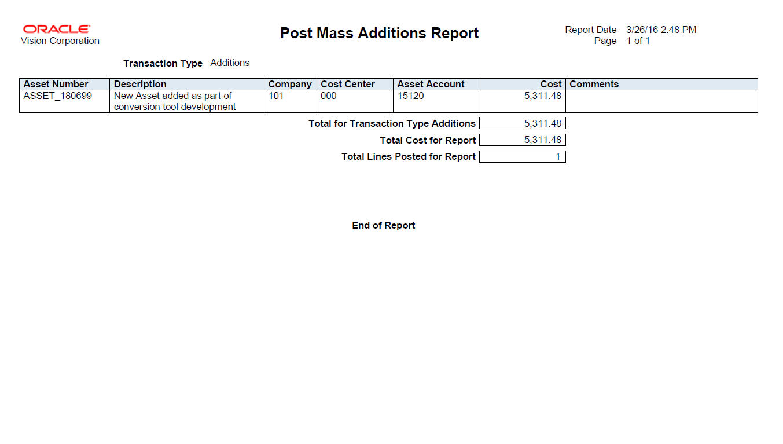

Stage 5: Data Validation and Reconciliation
All conversion scripts need to be tested before they can be used to load data into production. There are a number of activities that will need to take place before deployment can occur.
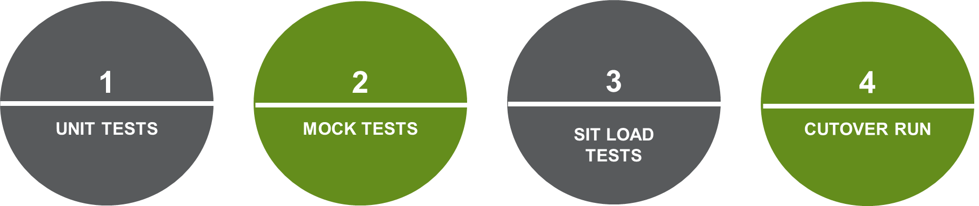
- Unit Tests: Once the development of the conversion scripts is complete, sample data will be used to test each script in isolation.
- Mock Tests: Mock conversion is carried out before the Integration Test Cycle.
- Mock testing of conversion objects is done using full data extracts; however sample data may be used when full data extracts are not available.
- SIT Load Tests: This testing will be aligned with Integration Testing (INT) - the data converted will be used in INT for application testing.
- This will allow us to load a full data set into a test environment to carry out reconciliation.
- Mock Cutover: As part of User Acceptance Testing (UAT) full end-to-end conversion will be carried out and fully reconciled and signed off with data owners and the relevant functional leads.
Business Data Owners need to reconcile the data imported into the Cloud ERP with the data in the legacy systems. Reconciliation includes comparing the number of records between legacy and cloud databases while validation includes comparing the data in the legacy and cloud databases.
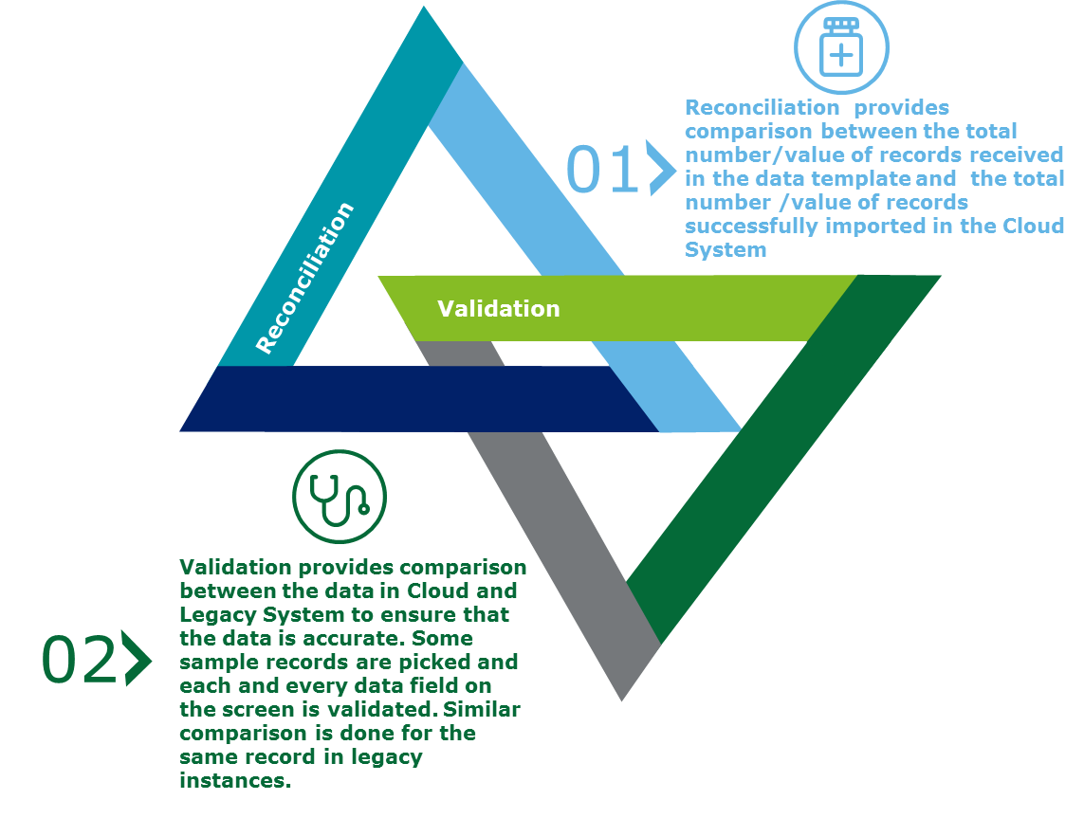
  - describe plans to manage dependency and data change management taking place during the course of the project execution (between data conversion and Implementation);
The implementation and conversion teams will collaborate and coordinate on an ongoing basis. If any process or requirements change during the implementation all relevant stakeholders will be involved before changes are made to the conversion approach. Based on this, an internal change request will be issued and the effort will be estimated based on the complexity. All change requests will be classified based on factors such as functional area, responsibility/accountability, etc. For example, data issues will be owned by legacy team, configuration and coding issues by the middleware team and Oracle product issues by the Oracle team.
  - indicate how quality assurance is embedded and demonstrated throughout the data conversion process;
We will start by examining our testing process followed by our data validation and defect management process.
Testing
Deloitte regards testing as a parallel process to development which will help the team work towards high quality output and reduce the constant cycling back to requirements.
Figure I3: Testing Approach
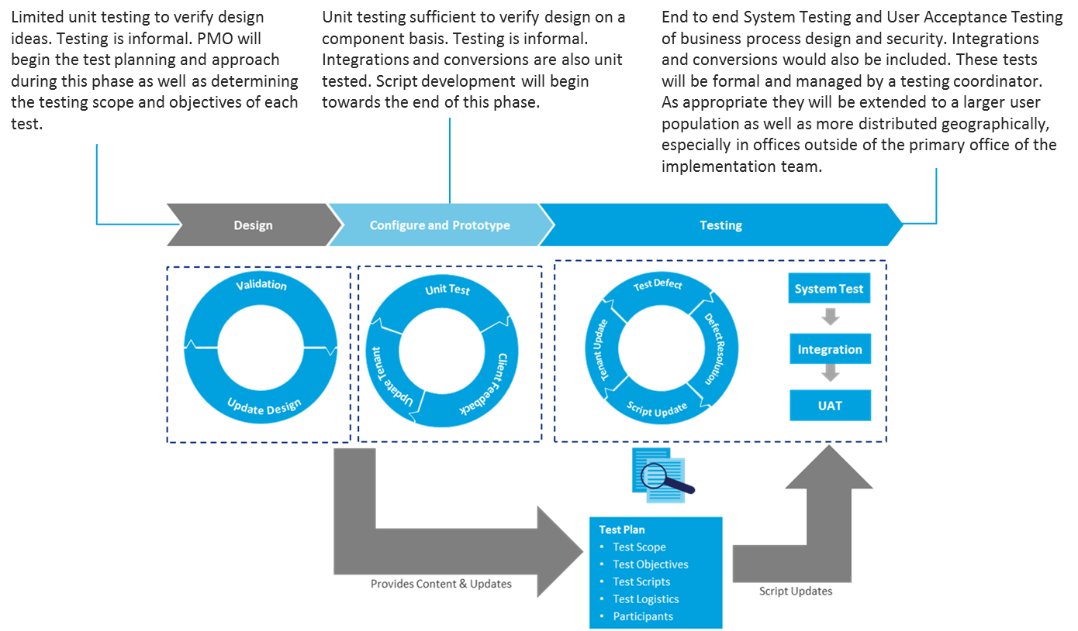
In our EVD methodology, testing is included as a set of activities within two specific disciplines (Process & Application and Technology), in multiple phases of the project. Within these two disciplines, we address two distinct types of testing:
- Functional Testing – Functional testing helps to confirm that the technology solution supporting the processes meets the process design and user requirements before the solution is fully released.
- Technical Testing – Technical testing helps to validate the technical environment and system integration tests related to data migration, software development, browser, interfaces, as well as performance testing.
Our approach uses an early allocation of testing team that involves a separate test team to carry out the continual integration testing for what is developed as the development sprints close.
Figure I4: Testing Team Structure & Rationale
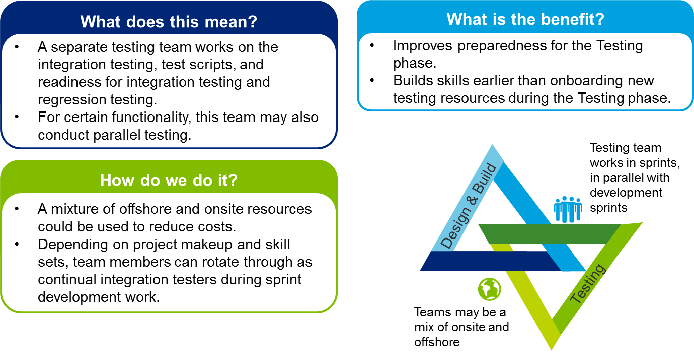
We rely on early test cycles to carry out Integration and Regression Tests of each developed module parallel to the development sprint to ensure that no part is broken due to continuous incremental development in the sprints.
To ensure constant agility we focus on test-driven development – which is the process of creating a limited code to pass a specific test scenario targeted for the development cycle. It is a concept of test first programming and encourages short development cycles and reduced defects.
Figure I5: Test-driven Development
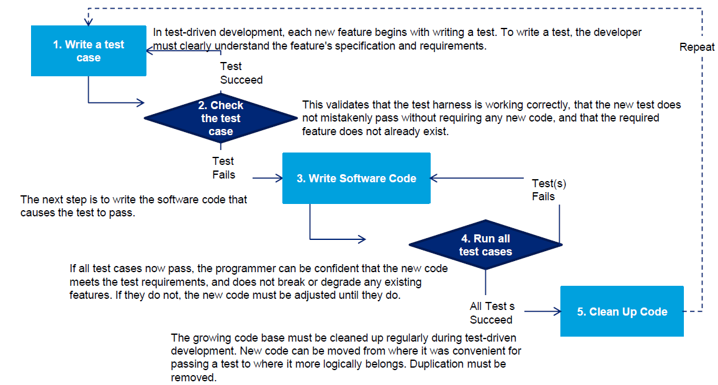
Development/configuration during each sprint is tested in conjunction with the development completed in the previous sprints.
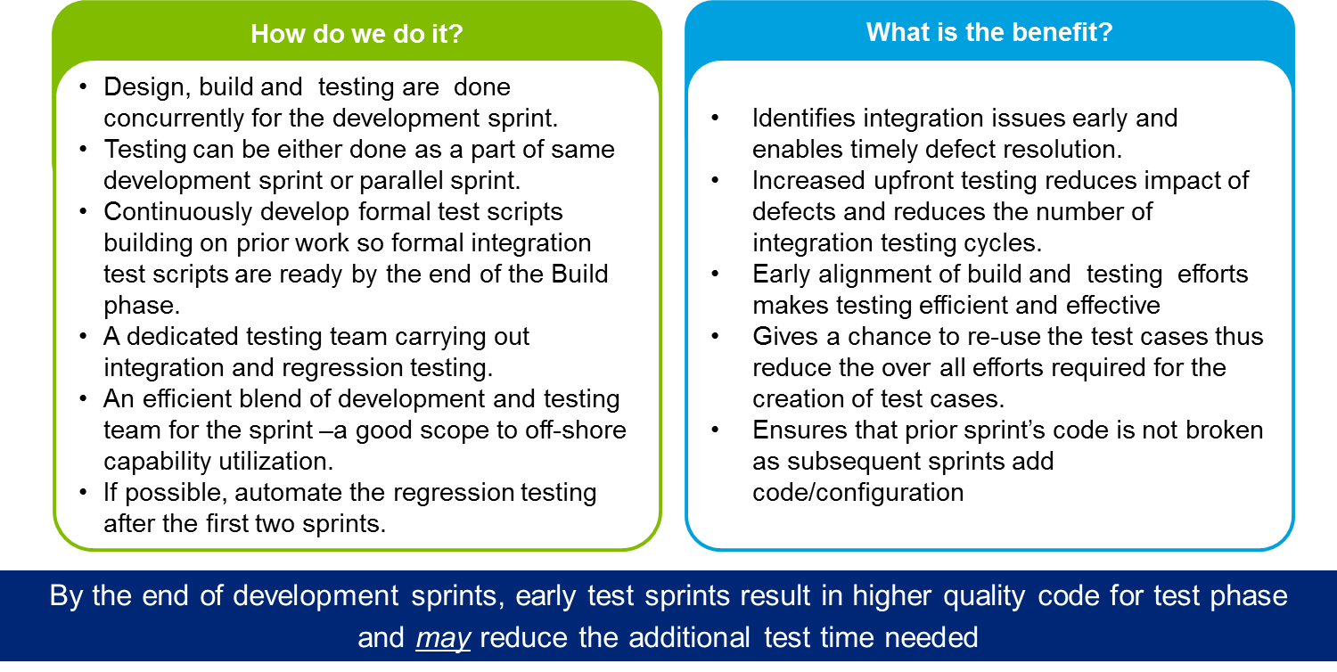
We will track testing activities across all testing stages in an integrated and efficient manner. This will help to create an end-to-end quality management infrastructure that validates the full functionality of the integrated solution across Oracle and complementary applications. The following table summarizes our proposed testing stages for the project:

Table below: Test types for Oracle Cloud Implementation Projects
Test Type | Primary Objective | Description | Expected GoA effort/ participation
Unit Test | Isolate each part or unit of the application and confirm functionality | - Conducted against the Technical Designs for Custom Objects only  - Serves to ensure that the piece of code satisfies the specified logic or behaviour  - Regression testing will be performed based on any changes to code or logic throughout the development and testing process | 20%
System Integration Test  (End-to-End Test) | Confirm end-to-end functionality of the integrated solution against business processes and business requirements | - Conducted against test cases and test data that are prepared using the Functional Design for custom objects  - Conducted against business scenarios that exercise end-to-end system functionality  - System test cases are “strung” together to orchestrate the integrated system functionality | 50%
User Acceptance Test | Confirm that the system functionality is acceptable to the Business prior to going live | - Conducted by leveraging the artifacts used for System Integration Test  - Ensure that the solution satisfies the business requirements and end-user expectations prior to being migrated into Production | 100%
During the Testing phase, we will complete two types of testing activities: System and Integration Testing and User Acceptance Testing.
- System Integration Testing: Testing will include Oracle Cloud business processes and system usage, data conversion, inbound and outbound integrations (legacy and third-party providers), reports, security roles, and user access.
- User Acceptance Testing (UAT): UAT is a test cycle that could include all aspects of the Oracle Cloud solution. UAT test execution will be performed by GoA-identified participants. Converted data supports the UAT process, but has no material impact on conversion.
At the end of UAT, a Go/No Go decision review will be conducted to approve the initiation of cutover to production systems.
System Integration Testing, reconciliation during data conversion testing and validation through User Acceptance Testing will—together—provide assurance that the system is functioning as expected.
Data Validation
We believe data is the foundation of the system so the testing and validation of it should be at the core of our test strategy. A data conversion could be technically accurate and yet the data could be useless to the business. Hence, it is imperative that the data being converted has the same utility/impact on the business as the original data would have had. Validating the accuracy and usefulness of the converted data requires collaboration between the technical and the functional teams. While the functional team is responsible for the final end-to-end verification of the data, the conversion team is responsible for monitoring the accuracy and integrity of data at each point in the conversion process. Data validation testing will follow a similar approach to SIT testing in that it will be performed across multiple sprints with each one resulting in higher quality results and the final test being performed and signed off by the end-users in UAT.
Performance Testing
Our approach includes a strong commitment to performance testing to ensure adequate levels of service for the government. It is common for performance issues to be identified during system integration testing and user acceptance testing but other issues may only appear once sufficient volumes/activity are present. We are recommending both a monitored approach to performance testing during the various testing sprints and phases, as well as formal performance testing to ensure optimal sizing and speed.
Defect Management
Defects will be entered and tracked during the UAT process, with each entry including detailed information about the defect. The Business Analyst role within the team will function as a liaison between the business and development teams to help prioritize and classify defects including conversions. Defects can be assigned one of four levels of severity:
- Regulatory – This request is regulatory and mandatory
- Critical – Testing defects that due to the complexity of the function or the scheduled dates are putting the implementation date at risk. No workaround exists.
- High – Testing defects occurring in a less complex function of the application with sufficient time to resolve before the implementation date – but must be implemented as scheduled. A workaround has been identified and is listed in the defect.
- Low – Testing defect occurring in a function that is simple to fix or could be excluded if not resolved by the scheduled implementation date.
Defects must be clearly captured and escalated to ensure prompt resolution by development but the objective is not to interrupt build sprints. The early testing cycles enable early detection and resolution of defects. Each defect submitted will be assigned a priority, worked by development, resolved, and re-tested prior to closure.
Figure I6: Defect Management
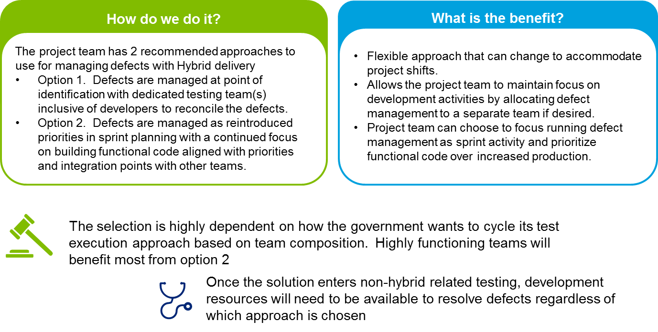
Deloitte has an extensive library of test scenarios to be leveraged by the government along with a comprehensive testing, tracking and defect management process.
Resolving Data Quality Issues
Data quality issues can be major roadblocks in realizing value from enterprise data. During a transition period where stored data becomes more closely examined, lingering data quality issues often surface and need to be addressed. Deloitte uses a risk based approach in identifying, managing, remediating and continuous monitoring.
The objective of the data quality approach is to be proactive in addressing data quality issues so that they don’t affect business or project activities.
Activity | Description | Potential Value to the Province
Analyze | A risk based approach is used to prioritize and determine the extent of any assessment or remediation activities.  An effective risk assessment process allows for effective and efficient assessment and remediation activities by focusing resources on areas of greatest risk. | Data Quality Impact Analysis  Initial data quality related observations based on initial scoping and data profiling activities.  Data Quality Risk Assessment  Assessment of operational, financial, compliance and project risks for each data source.
Assess | The data quality assessment focuses on identifying data quality issues using a comprehensive strategy including both profiling and business rule assessment.  The results of the assessment phase will guide the direction and extent of effort in the subsequent phases. | Data Profiling Results  Detailed profiling results for each data source.  Business and System Rule Listing by Object  Detailed listing of identified business and application system rules for each object and data source.  Business Rule Assessment Results  Detailed results of the business rule assessment for each data source.  Data Quality Exceptions Listing  Detailed listing of identified data quality exceptions for each data source.
Remediate | The remediation phase addresses any identified data quality issues.  More than just data cleansing, remediation is about understanding the data quality issues that are present and developing the appropriate solutions.  The risk assessment and data quality assessment are used to guide the extent of any remediation activities. | Data Quality Remediation Plan  Detailed remediation plan for each data source. Remediation plan will outline the remediation activities/plans for each data source.  Remediation  Fix at source – remediate identified source data within the origination application.  Fix on conversion – cleanse data one time before loading into target database (extract, cleanse, transform, load).  Fix in target – load data as is and set in place an ongoing program to cleanse data in target.  Mitigate – modify downstream applications and reporting to include updated logic on interpreting data with known issues.  Isolate – remove reliance on data with known quality issues, either by adapting current usage to suit a complementary element / dimension or ceasing usage of that element until quality issues are resolved.  Terminate – purge data with significant quality issues from the database and start generation of new data using a clean process.
Sustainable Monitoring | The sustainable data quality monitoring phase includes:  - Validating the target state data through re-performance of higher risk and/or key movements.  - Implementing a sustainable monitoring plan to monitor and maintain the quality of the data after it has been assessed and remediated. | Repeatable Data Quality Processes  Process creation for repeating activities performed during the Assess and Remediate phase in order to continually monitor data quality.
Data Quality issues can be hard to detect and their impact is difficult to quantify and articulate. Deloitte has extensive public sector and data quality knowledge and experience, which positions us to deliver a high-quality, risk-aware approach to identify and mitigate severe data quality issues. We will work with you to develop strategies to tackle these issues as they arise using Deloitte Tools and Accelerators.
Accelerator/Tool | Description | Benefits
Data Quality Dashboard  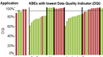 | The Data Quality Dashboard integrates with issue management platforms enabled remediation management. It also identifies source systems enabled root cause identification and resolution. | The Data Quality Dashboard allows for easy, intuitive and quick identification and prioritization of data quality issues.
Data Quality Weighting Model  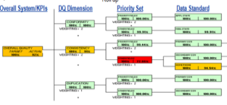 | The Data Quality Weighting Model provides data dimension weighting and priority template for key business data elements. | Data Quality Weighting Model allows for a fast risk based assessment of high risk data elements and dimensions.
  - confirm the organizational support that should be expected to support the continued data extracts and conversion activities;
The following table provides key responsibilities to support the conversion activities by phase.
Phase | Group | Key Responsibilities
Architect | Deloitte Functional Team | Complete required configurations for data import of all data entities in scope
Architect | Deloitte Development Team | Create and finalize conversion approach
Architect | GoA Team (Data Owners, Users) | Develop functional specification. Provide mapping for each data file (for all data entities in scope)
Configure and Prototype | Deloitte Functional Team | Provide support for configuration related issues. Help GoA team with data validation
Configure and Prototype | Deloitte Development Team | Develop, unit test and execute data conversions
Configure and Prototype | GoA Team (Data Owners, Users) | Perform data cleansing, provide sample data extracts from legacy environments for all data entities in format required by Oracle. Develop technical specification. Perform data validation
Test and Train | Deloitte Functional Team | Provide support for configuration related issues. Provide support for data validation
Test and Train | Deloitte Development Team | Execute data conversions into test environments
Test and Train | GoA Team (Data Owners, Users) | Perform data cleansing. Provide actual data extracts from legacy environments in format required by Oracle. Perform data validation
Deploy and Support | Deloitte Functional Team | Provide hyper care support to Operational team with any configuration related issues
Deploy and Support | Deloitte Development Team | Provide hyper care support to Operational team in executing data conversion into production
Deploy and Support | GoA Team (Data Owners, Users) | Use cleansed data extracts from legacy environments, execute data conversions, perform data validation and data reconciliation
  - describe expectations from the Province to ensure data conversion is effective and efficient;
Please refer to response above in section 2.0 (e).
  - list any assumptions or dependencies on which the proposed design is based;
Our assumptions related to data conversion and migration include, but are not limited to, the following:
- GoA will be responsible to determine and validate the data to be migrated (Master/Transactional).
- Three mock cycles will be considered for conversion.
- For data entities which had multiple counts, we estimated 1 at a high complexity and the others at a lower complexity.
- Conversions for ERP Cloud will be designed based on File Based Data Import (FBDI), ADFDI or Rapid Implementation approach. Any effort required to change the standard FBDI, ADFDi , Rapid implementation process are not in scope.
- Legacy systems can output data in FBDI template format for each conversion.
- Supplier conversion has been broken down by discreet FBDI upload program in ERP Cloud. Based on our experience, Supplier Bank conversion is often complex.
- Existing accelerators, if available for conversion, will be used and no new accelerator will be built.
- For high volume conversions we will use the out of box ERP cloud capabilities.
- During detailed design and discovery phase, the number of conversions and RICEW numbers and effort might change.
- CoA will be restructured as part of the GoA ERP program. This will require look up between the old and new CoA structures.
  - provide sample data conversion deliverables including mapping document, business rules document etc.;
Refer to the attached document below under Attachments, “Techno-Functional Specification (Conversion)”, for a sample data conversion deliverable which includes mapping of objects and business rules etc.
  - provide a sample data conversion plan including tasks, milestones, deliverables, and resources;
Refer to the attached document below under Attachments, “Mock Conversion Plan”, for a sample data conversion plan highlighting the tasks and sample deliverables such as Test case and conversion results and data validation templates etc.
  - describe any tools, processes or methods available for data migration;
Data Conversion from legacy to Oracle Cloud is based on the concept of Extract, Transform and Load and uses Oracle delivered File Based Loader (FBDI) tool. This provides significant savings in conversion execution time for the GoA. FDBI is a plug and play tool with negligible installation effort; it is also reusable and flexible across different project environments. Please refer to response in section 2.0 (b) for details around process and tools with data migration.
  - describe plans to manage dependency between data migration and Implementation;
Large transformational ERP programs have historically proven complex to organize, execute and evaluate and they often deviate from meeting the program objectives. While the deployment of an agile Cloud ERP service model brings new implementation approaches, we need to manage dependencies between data migration and a successful software implementation. This requires a focus on collaboration, design and strong governance.
Vendor Collaboration:
It is critical to quickly establish a collaborative model and set expectations, formulate a comprehensive communication plan and establish roles and responsibilities between the GoA, Deloitte, software vendors, and the support organization. There are three main principles for achieving a strong and trusted working relationship:
- Build a strong, open and honest relationship and partner for the success of the program.
- Communicate ‘early and often’ to ensure complete engagement and transparency with partners.
- Establish a plan for release updates.
Importance of Design:
A digital transformation can be seen as a more incremental and agile journey where a culture of ‘fail and learn’ is encouraged. A key to the success of this model is the importance of the design process that will support the program by:
- Leveraging our process and technology experience to consider impacts across process and functions and identifying dependencies.
- Clearly articulating the requirements to ensure that proposed solutions result in the expected outcomes. Leverage different points of view, including those of process owners and end users, to understand what matters.
- Standardizing and simplifying processes across ministries – this will foster collaboration, promote data transparency and more agile and innovative ways of working.
- Following a logical order that gains agreement on ‘building blocks’ first and develops these concepts.
- Tackles complex or contentious areas early to allow prototyping and reflection to guide stakeholders towards the right decisions.
- Emphasising the agile principle of high-velocity decision-making, or “a bad decision is better than no decision”.
Identifying and empowering the right team that can define and agree on how business will operate in the future will lead to a successful design phase and a more successful implementation
Strong Governance:
The advent of Cloud ERP delivery models has led to a perception that deployment is faster and easier. One area that is still critical to success is the governance model. Cloud system programs require governance that:
- Recognizes the important role of Oracle as a service provider under the new model, alongside Deloitte as the delivery partner.
- Understands that increased agility and speed does not result in less governance but rather a different governance model that clearly documents roles, responsibilities and authorities whilst supporting agility, collaboration and high-velocity decision-making.
- Has buy-in from all project members and stakeholders. Cloud deployments are typically quicker than an on premise waterfall-method deployment and the pace can be intense. It is even more important to maintain the right discipline during these implementations.
We will work with the Province to review your IMT governance framework against our Deloitte EVD Cloud method and agree on a blended governance approach that is digital and that will lead to success.
  - describe risks and recommend risk remedial actions for data migration;
Data conversions are resource-intensive, complex, time-consuming and iterative in nature. Every organization has validations that are specific to their existing business processes and practices. These validations need to be performed on data across ERP modules along with standard mappings while moving to a new ERP landscape. Business and IT must acclimatize to new terminology along with new business and IT standards, which are critical to performing data cleansing and data validations during conversions.
The following diagram provides risks, impacts and mitigation strategies for conversion activities.
Figure I7: Data Migration Risks and Mitigations
  - describe expectations from the Province to ensure data migration is effective and efficient; and
Refer to response in 2.0 (f) above.
  - provide sample data migration deliverables including data validation reporting.
Refer to the attached spreadsheet under Attachments, “Invoice Conversion Audit Report”, for a sample data migration and validation report.

Table I |  | Data Conversion and Data Migration
3.0 | Data Migration
The Pre-Qualified Proponent should provide a preliminary data migration strategy. The strategy should include an:
- approach and plan to complete data migration, both exporting and importing; and
- approach to complete data migration testing.
The Proposal should:
- describe plans to manage dependency between data migration and Implementation;
- describe the approach toward data migration, detailing what methods, tools, technologies, templates or processes you recommend for the extract, transformation and loading (ETL) supporting the overall migration;
- indicate how quality assurance is embedded and demonstrated through the proposed data migration approach;
- describe the approach to data validation, verification and business approval on completion of the migration;
- describe how cut-over planning will include data needs apart from technical solution cut-over planning;
- describe risks and recommend risk remedial actions for data migration;
- describe expectations from the Province to ensure data migration is effective and efficient;
- provide sample data migration deliverables including data validation reports; and
- provide a sample data migration plan including tasks, milestones, deliverables, and resources.
Pre-Qualified Proponent Comments:
  - describe plans to manage dependency between data migration and Implementation;
Please see response provided in section 2.0 (k) above.
  - describe the approach toward data migration, detailing what methods, tools, technologies, templates or processes you recommend for the extract, transformation and loading (ETL) supporting the overall migration;
Please see response provided in section 2.0 (j) above.
  - indicate how quality assurance is embedded and demonstrated through the proposed data migration approach;
Please see response provided in section 2.0 (d) above.
  - describe the approach to data validation, verification and business approval on completion of the migration;
Please see response provided in section 2.0 (d) above.
  - describe how cut-over planning will include data needs apart from technical solution cut-over planning;
Cutover Planning is a key step to successful transition to cloud system. The following are some of the key steps in the cutover process.
- Develop a Business Freeze Calendar to include key business and system cutoffs.
- Plan ramp-down operations in the legacy systems and ramp-up operations in the new systems.
- Plan data extracts, conversions, and reconciliation of data from legacy systems into new systems in an efficient manner.
- Develop a detailed cutover plan to orchestrate business and system activities.
- Rehearse the cutover plan (mock cutover) leading up to user acceptance testing and make adjustments based on feedback from the rehearsal.
- Minimize business disruption and business risks and develop mitigation plans.
- Document impacts of cutover on the business functions.
- Perform a controlled production pilot during go-live cutover week.
- Work to freeze and minimize open transactions during the cutover.
- Control changes to the production environments (e.g. patches, configurations, data, migrations) leading up to go-live.
Figure I8: Deloitte Cutover Strategy
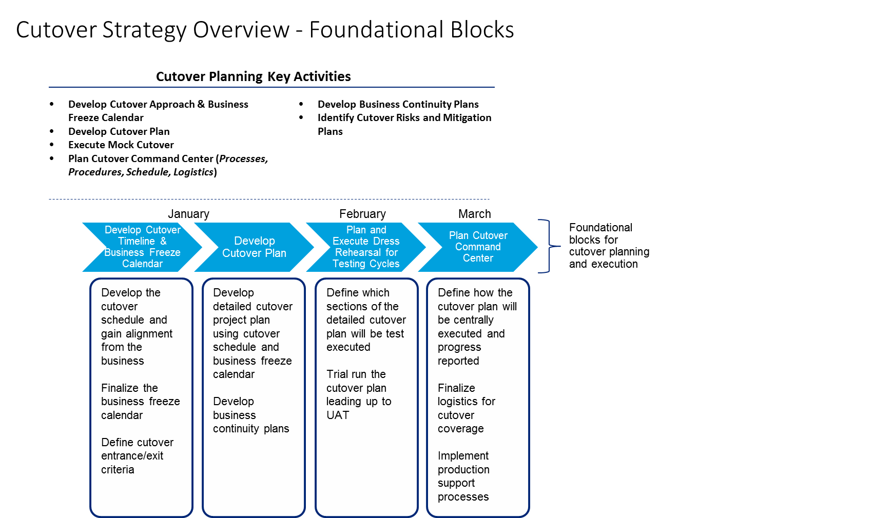
  - describe risks and recommend risk remedial actions for data migration;
Please see response provided in section 2.0 (l) above.
  - describe expectations from the Province to ensure data migration is effective and efficient;
Please see response provided in section 2.0 (f) above.
  - provide sample data migration deliverables including data validation reports; and
Please see response provided in section 2.0 (n) above.
  - provide a sample data migration plan including tasks, milestones, deliverables, and resources.
Please see response provided in section 2.0 (i) above.

Attachments

Techno-Functional Specification (Conversion)

Mock Conversion Plan

Invoice Conversion Audit Report

